**Project Preliminary Report on**

**“SMART WHEELCHAIR FOR PARALYZED”**

A PROJECT REPORT

Submitted by

**KNR18EE024. JASIRA T P**

**KNR18EE034. NAYANA RAMESHAN**

**KNR18EE046. SHRAVAN SREEDEEP**

**KNR18EE048. SOORYA P**

*under the Supervision of*

Dr. C SREEKUMAR

**to**

the APJ Abdul Kalam Technological University

in partial fulfillment of the requirements for the award of the Degree

of

Bachelor of Technology

in

*Electrical & Electronics Engineering*



**Department of Electrical & Electronics Engineering**

**Government College of Engineering Kannur- 670563**

**JANUARY 2022**

**ABSTRACT**

Paralyzed stroke patients are unable to normally communicate with their environment. For these patients, the only part of their body that is under their control, in terms of muscular movement, is their eyeballs.

The biggest problem that paralyzed patients face is leading their own life without others support. This include basic day to day operations like switching on basic devices like fan, bulb etc.

An automated working prototype of a smart wheel chair working with a home automation system that can be controlled by eye tracking is implemented in this work. The prototype is designed for the paralysed people with only motor functions for eye movement. This method takes care of surrounding obstructions and decisions are taken accordingly.

**CONTENTS**

|  |  |  |
| --- | --- | --- |
| **Title Page** |  | **i** |
| **Abstract** |  | **ii** |
| **Contents** |  | **iii** |
| **List of Figures** |  | **iv** |
| **CHAPTER 1** | **INTRODUCTION** | **1** |
| **CHAPTER 2** | **LITERATURE REVIEW** | **2** |
| **CHAPTER 3** | **METHODOLOGY** | **4** |
|  | 3.1 PROPOSED METHOD FOR WHEELCHAIR | 4 |
|  | 3.2 BLOCK DIAGRAM | 4 |
|  | 3.3 PROPOSED METHOD FOR HOME AUTOMATION | 6 |
|  | 3.4 SYSTEM ALGORITHM FOR EYE PUPIL DETECTION | 7 |
|  | 3.4.1 Face Detection And Eye Detection | 7 |
|  | 3.4.2 BGR to Gray Conversion | 7 |
|  | 3.4.3 Features Detection And Blurring Image | 8 |
|  | 3.4.4 Edge Detection | 8 |
|  | 3.4.5 Eye Tracking | 8 |
| **CHAPTER 4** | **STATUS OF PROJECT WORK** | 9 |
|  | 4.1 SIMULATION OF SMART WHEEL CHAIR | 9 |
|  | 4.2 SIMULATION RESULTS | 9 |
|  | 4.2.1 Eye Tracking Model | 9 |
|  | 4.2.2 Wheelchair Model Simulation Results | 10 |
|  | 4.2.3 Raspberry Pi 4 Model B | 12 |
| **CHAPTER 5** | **CONCLUSIONS** | **13** |
| **REFERENCES** |  | **14** |

**LIST OF FIGURES**

|  |  |  |
| --- | --- | --- |
| No | Title | Page No |
| 3.1 | Block Diagram of Smart Wheelchair | 4 |
| 3.2 | Flowchart of working for Wheelchair Movement | 6 |
| 3.3 | Circuit Diagram for Home Automation System | 6 |
| 3.4 | Coordinates system with respective eye position | 8 |
| 4.1 | Simulation Model of Smart Wheelchair | 9 |
| 4.2 | Eye Tracking Results | 10 |
| 4.3 | When Eye pupil are centred. | 10 |
| 4.4 | When Eye pupil are to the left. | 11 |
| 4.5 | When Eye pupil are to the right. | 11 |
| 4.6 | When Eye pupil are down. | 12 |
| 4.7 | When Eye pupil are up position. | 12 |
| 4.8 | Raspberry Pi 4 Model B 4GB Ram | 13 |
|  |  |  |

**CHAPTER 1**

**INTRODUCTION**

The Wheelchair is a dependent system used by elderly and physical disable persons. Here we are introducing the design implementation model of a totally independent Eye controlled electric wheelchair. For a totally paralyzed person it is very difficult to use controller type of electric wheel chair. Here the Eye control system provides the independence to make their life easy and more convenient. And also they save huge amount of energy or external man power.

Camera captured the image in real time and analysis the image as input to set the commands for interface the motor driver IC through sending the commands to GPIO pins. The motor driver circuit is used to perform the different operation such as left, right, forward and stop. For the advance level of Image Processing open computer vision (OpenCV) library is used for Face and Eye detection. Google’s MediaPipe library is used to find out accurate pupil location detection and tracking of that.

An Eye tracking technique, which capture the image and detects the presents of human face. After detecting the face, it detects area of the eye location on the face detected image, and performs several operation of basic image processing like colour image to grey conversion, filtering, threshold, pattern matching, noise reduction and circle detection on it.

The Raspberry pi board is used to perform the control of the complete system operation. Digital Image processing based output signal sent to the Raspberry pi board. The Raspberry pi acquired the data and analyse it. Raspberry pi send the control signal to motor driving circuit based on the location of eye pupil. In a Wheelchair two individual motors are embedded on each wheel. The Ultrasonic sensor is also mounted on the wheelchair for detection of any static or mobile obstacle. If sensor gets the obstacle very close to the wheelchair, it will indicate to the raspberry pi and raspberry sends the signal to motor driving circuit to stop the motor.

**CHAPTER 2**

**LITERATURE REVIEW**

Ahmad F. Klaib’s [1] study aims to explore and review eye tracking concepts, methods, and techniques by further elaborating on efficient and effective modern approaches such as machine learning (ML), Internet of Things (IoT), and cloud computing. These approaches have been in use for more than two decades and are heavily used in the development of recent eye tracking applications. The results of his study indicate that ML and IoT are important aspects in evolving eye tracking applications In addition, he show that eye tracking techniques have more accurate detection results compared with traditional event-detection methods. Promodini A Punde [2] studied various methods for eye tracking technology to get data about the user’s vision when the user is performing his routine task using smartphone cameras and web-camera. Tan Kian Houhe [3] built an Arduino based voice controlled wheelchair prototype and successfully tested to respond to voice commands. The Arduino microcontroller processes the voice command from the speech recognition module and controls the motor movement of the wheelchair. Bluetooth module was also used to do away with messy wiring and an optional joystick command was also incorporated into the prototype design. The review paper from Mohammed Hayyan Al Sibai [4] presents different smart technologies for wheelchairs. It focuses on two main properties: The human - machine interface and the navigation methods and devices. Also it reviews other smart systems like monitoring and safety systems. The authors Deepak Kumar, Reetu Malhotra, S. R. Sharma [5] made a chair that acts as a moving chair and a wheelchair (with foot mat during rainy days) depending on the need of a person. A wheelchair provides the umbrella, Foot mat, Head mat, and obstacle detection, which does not depend on the ability to participate in society. While all other papers focused on eye tracking based wheel chair, Georges Boustany [6] focused on eye tracking based home automation system. The solution is targeted for people suffering from locked in syndrome. The proposed system is able to control doors, window shutters, lightings, bed control, television set, and heating ventilation and air-conditioning. When Georges Boustany made a system for paralyzed people, Joseph K George [7] scaled down the design using microcontrollers instead of bulky computers. The device here incorporates activation and deactivation of appliances such as fan, bulb, GSM and alarm. EOG acquisition is a more primitive method for tracking eyeball movements, technical capability of this method is due to poor noise to signal ratio & also precise filters are required for this method. The method of eye tracking using camera requires a fully dedicated system with image processing software during the entire working of the unit.

**CHAPTER 3**

**METHODOLOGY**

**3.1 PROPOSED METHOD FOR WHEELCHAIR**

This system is totally autonomous system, and all the module will work independent each other. For the basic requirement of the any electronic system is Power supply. In this system there is mandatory to gives the proper power supply to individual components, and the standard power supply should be used for Raspberry pi, camera, sensor, and motors. The Raspberry pi board is brain of wheelchair. In proposed system model the module like monitor, camera, power circuit and Wi-Fi Adapter is directly connected through the Raspberry pi board. And Raspberry pi board is connected to the internet for remote access facilely, In case emergency controlling or monitoring the status of wheelchair, will be carried out by access the raspberry pi board at remote place using web-server (internet).

**3.2 BLOCK DIAGRAM**

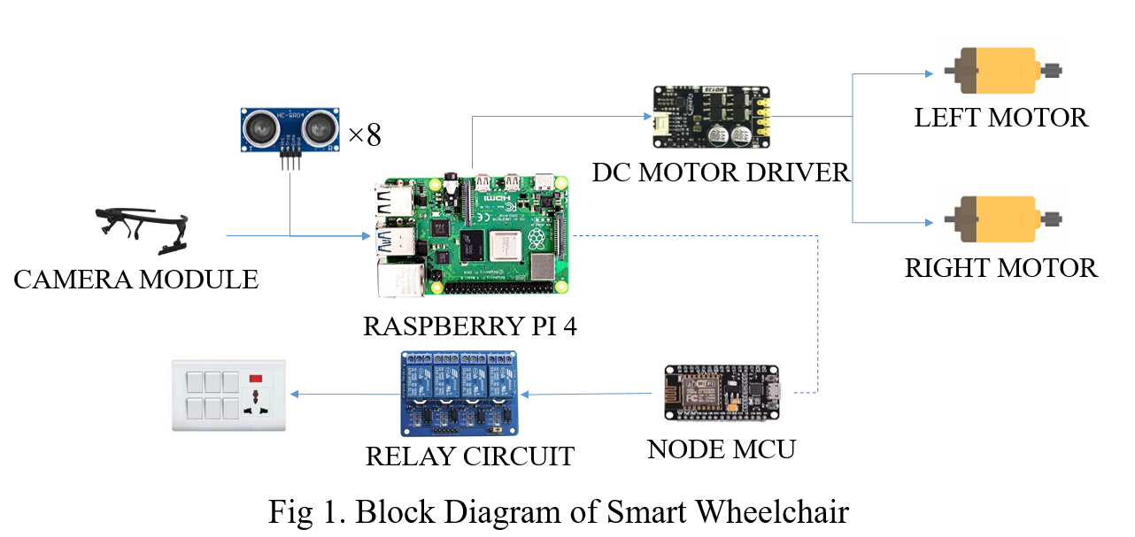

Fig 3.1 Block Diagram of Smart Wheelchair

For capturing the image a 5 MP web camera is used in our system. The Raspberry gives the commands to the motor driver circuit, which is enable the GPIO pin to perform operation. Such as forward, left, right and stop operation performed based on eye movements. Sensors are also mounted on the head of wheelchair for detecting the obstacles and controlling the wheelchair. Ultrasonic sensor is used for detecting the obstacle or any moving object in front of wheelchair. The sensor is directly connected to the Raspberry pi board, it acquired the data and measuring the distance between wheelchair and obstacle.

This system is comes under real time data acquisition, data processing and controlling system. There is real time video capturing and advance image processing used on it. For using Raspberry pi board, they have its own operating system is known as “Raspbian”, which is Linux based operation system and also compatible with raspberry pi board.

To detect the exact eye pupil location is very challenging. A new image processing technique used for eye pupil center detection and tracking, which works based on open computer vision (OpenCV) library. Most of coding part done with the help of OpenCV library. Google’s MediaPipe library is used to find out accurate pupil location detection and tracking of that. Python language is used for codding, which is user friendly and helpful to resolve the error efficiently.

For home automation system, the raspberry pi connects with the Node MCU when it enters its range. This will enable raspberry pi to control home appliances. Control signals are generated using combination of blink and position of eye balls.

First camera module will start to capture the images. For the face detection mediapipe library is used. After detection of proper face, it will trying to detect the eye inside the face region of interest. And again mediapipe library is used like as face detection to detect eye. It will draw the rectangular box over the Eye. Now, the main target is to detects the eye pupil and define its center points. There is several image processing operation performed in system, such as blur Image, color conversion, thresholding, filtering, edge detection and Hough transform is used. For circle detection Hough transform method is used. By using the USB webcam allowed to capture the images on raspberry. And Image Processing based all OpenCV library are installed in raspberry pi memory. There it will process and work without any processing delay. The figure 3.2 shows the Flowchart of system working.

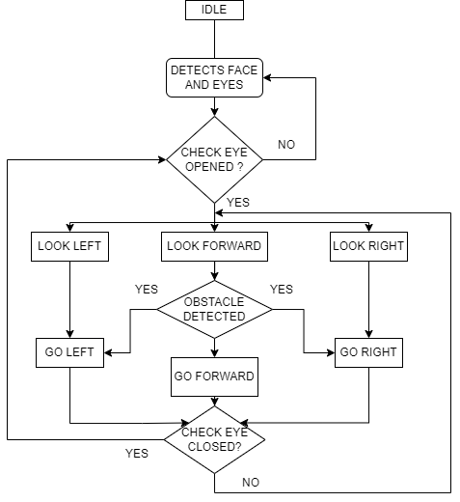

Fig 3.2 Flowchart of working for wheelchair movement

**3.3 PROPOSED METHOD FOR HOME AUTOMATION**

The circuit diagram of the system is as shown in Fig 3.3. The whole circuit is divided into 2 parts. The Node MCU controller which acts as a slave controller for Raspberry Pi 4 and the relay switches for controlling different devices. The Node MCU connects with Raspberry Pi when the controller enters the range of the same. Control signals are produced based on blink and movement combinations of eye pupil to control the home appliances.

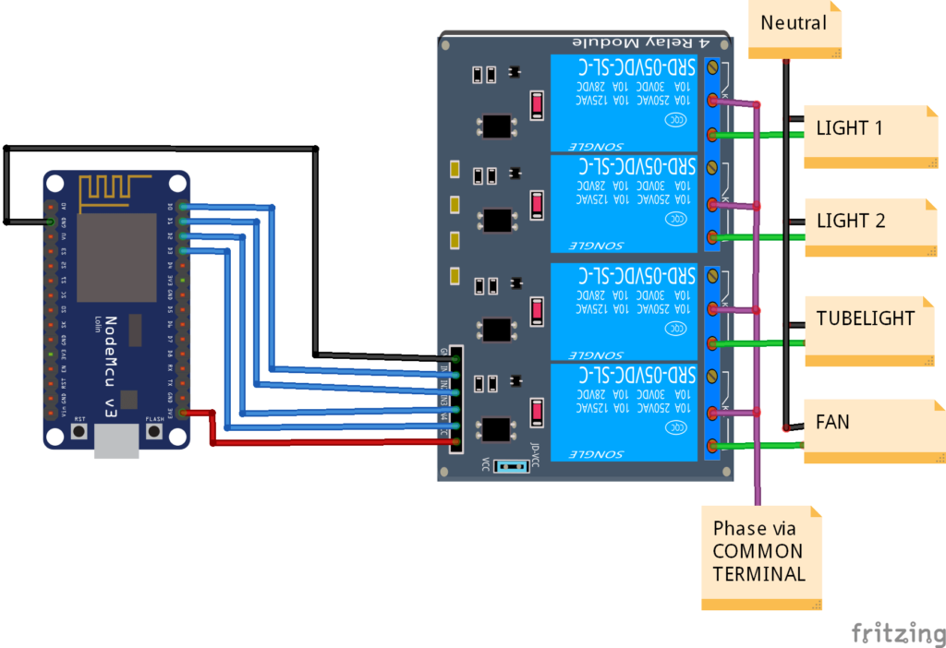

Fig 3.3 Circuit Diagram for home automation system

**3.4 SYSTEM ALGORITHM FOR EYE PUPIL DETECTION**

In our system open computer vision (OpenCV) free access library algorithm used for Image processing. The OpenCV library play a very important role, and it gives the knowledge of Image processing. A novel algorithm used for system execution and perform the operation. To find out the pupil center point of the Eye, we followed some steps:

**3.4.1 Face Detection and Eye Detection**

For the face detection and eye detection the OpenCV library is used directly. A system camera detects the face of user. Once it will detected, system finds the eye location and marks the eye region using Mediapipe library. And system accurately detect both the eyes based on the proper distance of the each other.

**3.4.2 BGR To Gray Conversion**

A very next operation of the image color convention to reduce the system delay time. The Image frame size should be low, because the processor cannot processing the image frames in run time condition. So, by using the BGR to GRAY conversion a colored image converted into gray image.

**3.4.3 Features Detection and Blurring Image**

The Gaussian blur filter is used for blurring the image. Which helps to detect the exact edges of specific area of the cropped image. Features is nothing but it found some special pattern on image which is unique, based on it will make a pattern.

**3.4.4 Edge Detection**

A canny Edge detection and corner edge detection algorithm is applied for determine the soft edges of the image. To set the proper threshold value it will allowed easy to recognize rectangles or circle presented in Image.

**3.4.5 Eye Tracking**

To track the Eye movements we use projection function algorithm was used, where the coordinates system points the eye centre point location. In Fig 4.1 indicates the eye pupil location with respective coordinate’s system graph.



Fig 3.4 Coordinates system with respective eye position

**CHAPTER 4**

**STATUS OF PROJECT WORK**

**4.1 SIMULATION OF SMART WHEELCHAIR**

The simulation was done using proteus design suite. The model of smart wheelchair is shown in Fig 4.1.

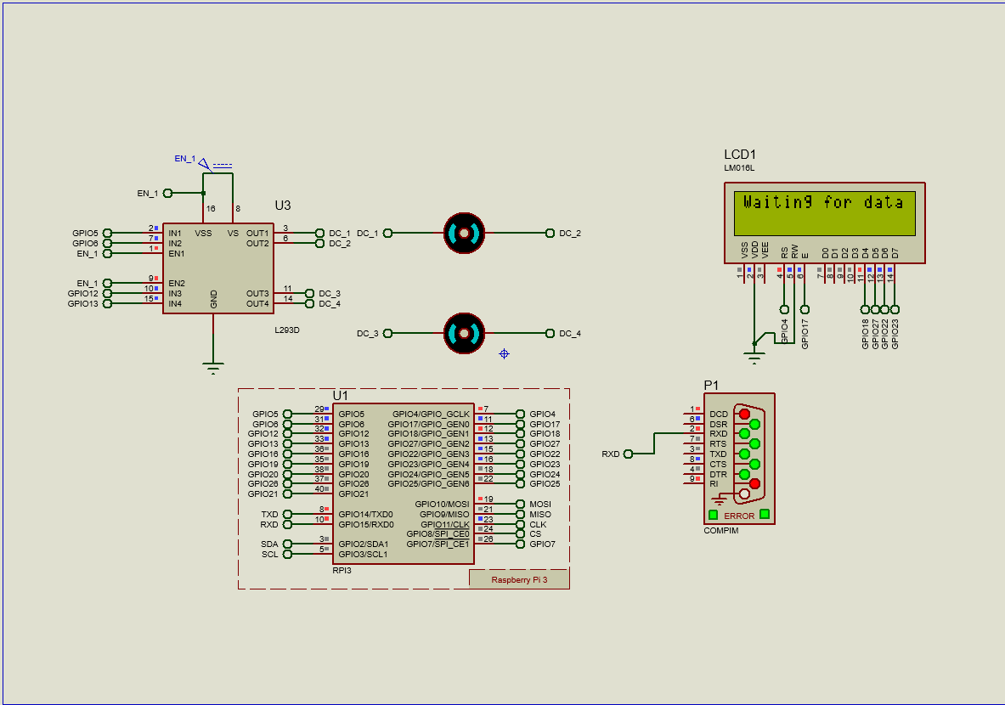

Fig 4.1 Simulation Model of Smart Wheelchair

In simulation, 2 DC motors of 24V is used with motor driver circuit for controlling the motors. The signals from the eye tracking program is transferred to the Raspberry Pi 4 model of proteus design suite. To identify the control signals and LCD monitor is connected to the Raspberry Pi 4.

**4.2 SIMULATION RESULTS**

The results of the smart wheelchair and eye tracking models are provided below. The model was programmed in python language.

**4.2.1 Eye Tracking Model**

The result for eye tracking program is shown below.

|  |  |
| --- | --- |
| a. Center | b. Closed |
| c. Left | d. Right |

Fig 4.2 Eye Tracking Results.

**4.2.2 Wheelchair Model Simulation Results**

The result for smart wheelchair model using proteus design suite is shown below.

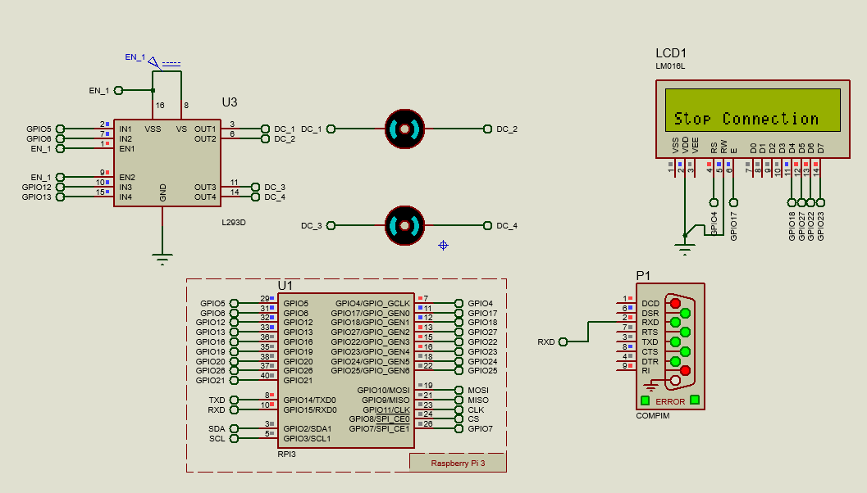

Fig 4.3 When Eye pupil are centred.

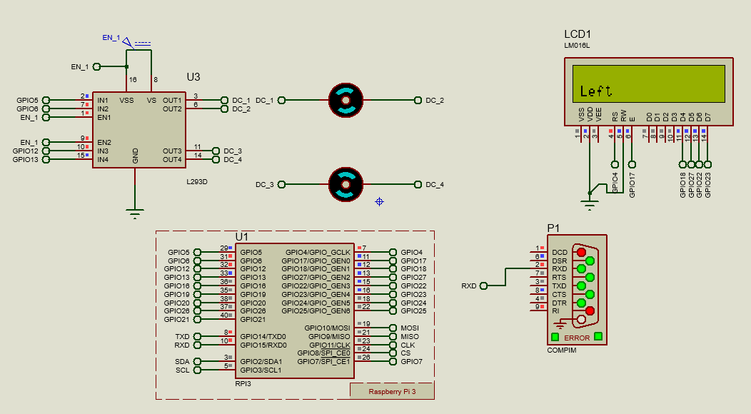

Fig 4.4 When Eye pupil are to the left.

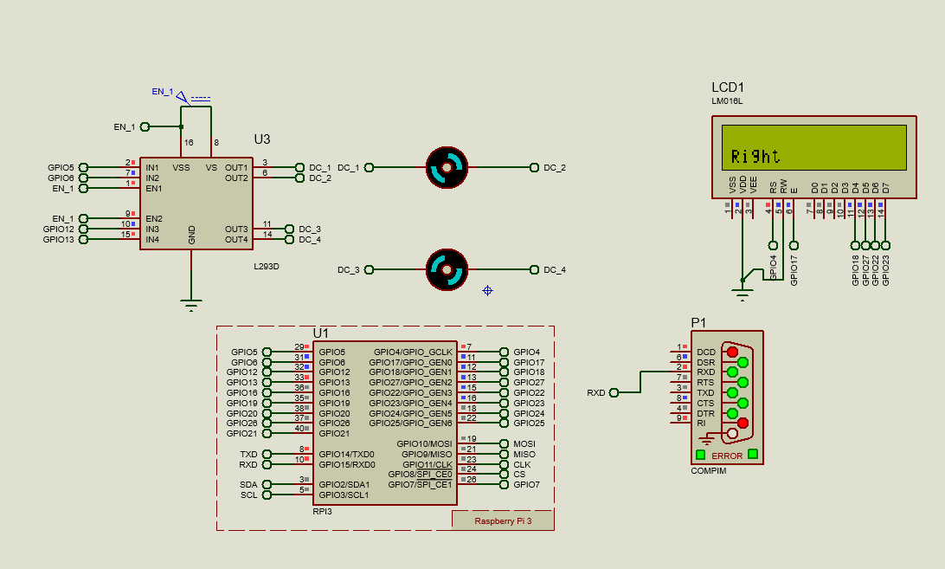

Fig 4.5 When Eye pupil are to the right.

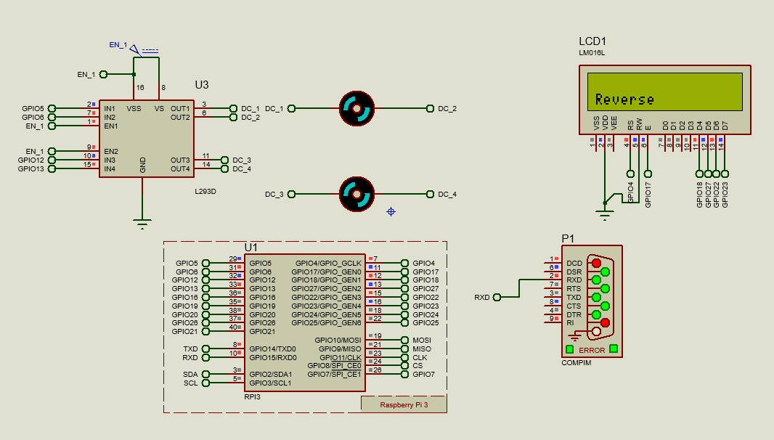

Fig 4.6 When Eye pupil are down.

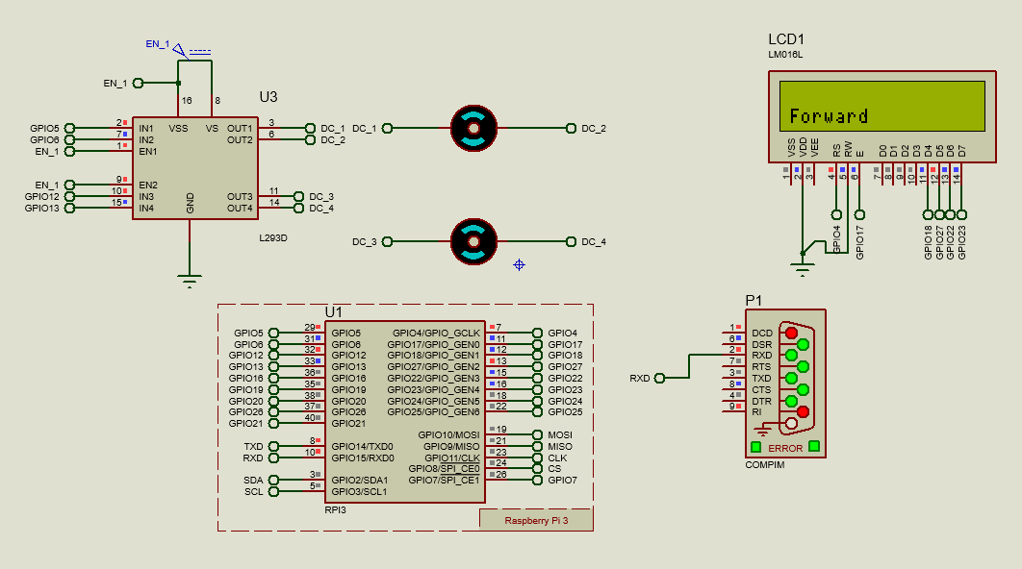

Fig 4.7 When Eye pupil are up position.

**4.2.3 Raspberry Pi 4 Model B**

. Raspberry Pi 4 Model B with 4GB ram is acquired and tested for functionality.

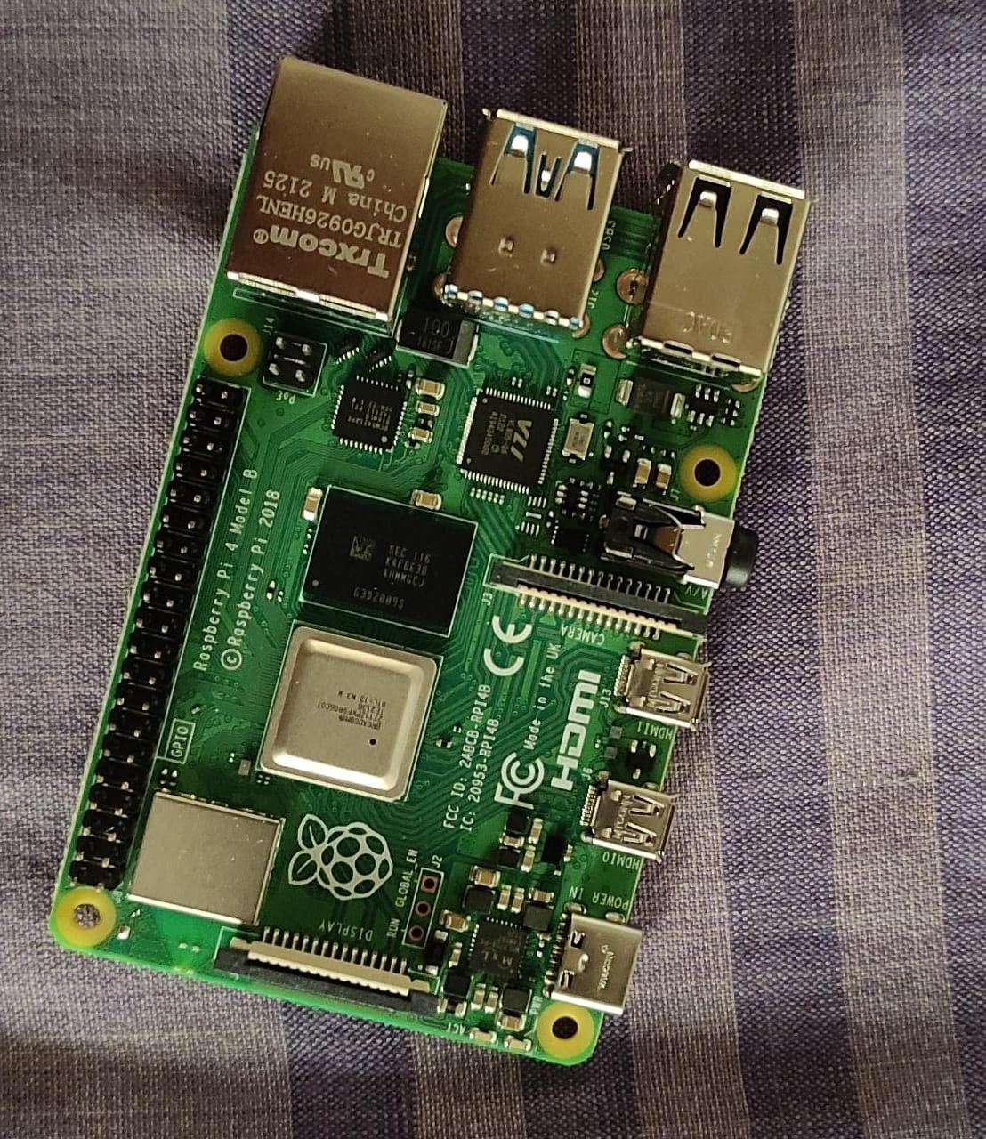

Fig 4.8 Raspberry Pi 4 Model B 4GB Ram

**CHAPTER 5**

**CONCLUSION**

Paralyzed stroke patients are unable to normally communicate with their environment. The biggest problem that paralyzed patients face is leading their own lives without the assistance of others. As a solution to this problem, a smart wheel chair working with a home automation system that can be controlled by eye tracking is implemented in this work. The literature review for the proposed model are going on.

The eye tracking model is developed in python language using opencv and mediapipe libraries. Eye tracking technique, captures the image and detects the presence of human face. It detects the location of the eye on the face and conducts basic image processing operations such as color image to grey conversion, filtering, threshold, pattern matching, noise reduction, and circle detection on it after recognizing the face.

For the base controller, Raspberry Pi 4 has been selected. The Raspberry Pi board is utilized to control the entire operation of the system. It receives a signal based on digital image processing. The data was collected and analyzed using the Raspberry Pi. Based on the location of the eye pupil, the Raspberry Pi sends a control signal to the motor driving circuit. Two separate motors are placed in each wheel of a wheelchair. The wheelchair also has an ultrasonic sensor for detecting any stationary or moving obstacles. If the sensor detects an impediment that is quite close to the wheelchair, it will alert the Raspberry Pi, which will send a signal to the motor driving circuit to turn off the motor.

After the presentation, it is decided to implement the project provided by Government College of Engineering Kannur.

**REFERENCE**

1. **Ahmad F. Klaib, Nawaf . Alsrehin, Wasen Y. Melhem, Haneen . Bashtawi, Aws A. Magableh**. “Eye Tracking Algorithms, Techniques, Tools, and Applications with an Emphasis on Machine Learning and Internet of Things Technologies”, September 2020
2. **Pramodini A. Punde, Dr. Mukti E. Jadhav, Dr. Ramesh R. Manza**, “A study of Eye Tracking Technology and its applications”, *IEEE* 2017
3. **Tan Kian Hou, Yagasena and Chelladurai**“Arduino based voice controlled wheelchair”, 2020
4. **Mohammed Hayyan Al Sibai, Sulastri Abdhul Manap**, “A Study on Smart Wheelchair Systems”, *Research Gate* Dec 2015
5. **Deepak Kumar, Reetu Malhotra, S R Sharma**, “Design & Construction of a Smart Wheelchair”, *Science Direct* 2019
6. **Georges Boustany, Alaa El Deen Itani, Rayan Youssef, Omar Chami, Ziad O. Abu-Faraj**, “Design and Development of Rehabilitive Eye-Tracking Based Home Automation System”, *IEEE* 2016
7. **Joseph K George, Subin K B, Arun Jose, Hima T**, “Eye Controlled Home-Automation For Disables”, *IOSR-JEEE* 2017
8. **Deepak Kumar Lodhi, Prakshi Vats, Addala Varun, Prashant Solanki, Ritakshi Gupta1, Manoj Kumar Pandey, Rajat Butola**, “Smart Electronic Wheelchair Using Arduino and Bluetooth Module”, *IJCSMC* May 2016
9. **Airi Ishizuka, Ayanori Yorozu and Masaki Takahashi**, “Driving Control of a Powered Wheelchair Considering Uncertainty of Gaze Input in an Unknown Environment”, *MDPI*, 2018
10. **Mohammed Hayyan Al Sibai and Sulastri Abdul Manap**, “A Study on Smart Wheelchair Systems”, *International Journal of Engineering Technology and Sciences*, 2015
11. **Mohammad A.Eid, Nikolas Giakoumidis and Abdulmotaleb EL Saddik**, “A Novel Eye-Gaze-Controlled Wheelchair System for Navigating Unknown Environments: Case Study with a Person with ALS”, *IEEE Access*, 2016